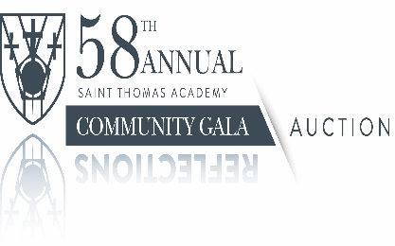
Saint Thomas Academy
2023 Community Auction Sponsorship Opportunities

Saint Thomas Academy is an expert in educating and developing boys. Our mission – to develop boys into men of character – is our promise to students, families, the community, and the world. We accomplish this through the transformative power of an educational and life experience deeply rooted in the Catholic faith and traditions, academic excellence, military leadership, and an all-male environment.

We invite you to further our mission and make an Academy education more accessible to qualified students by sponsoring the 2023 STA Community Auction, a fundraising event that supports students, faculty, and co-curricular programming.

As a sponsor, your business will receive valuable awareness among the entire Saint Thomas Academy community, a very loyal community whose members appreciate your support.

58th STA Auction Sponsorship Levels

REFLECTIONS - $10,000
Table of 10
Premium Seating
Chocolates at Table
Take Home Gift for each Guest
Premium Wine and Champagne
Recognition at Auction
Company Logo on Auction Website

COMMUNITY - $5,000
Table of 10
Preferred Seating
Chocolates at Table
Upgraded Wine at Dinner
Recognition at Auction
Company Logo on Auction Website

ACADEMY - $3,000
Table of 10
Upgraded Seating
Chocolates at Table
Recognition at Auction
Company Logo on Auction Website

CADETS - $2,000
Table of 10
Chocolates at Table
Recognition at Auction

Yes! We want to be a 2023 STA Auction Sponsor.

_____ REFLECTIONS - $10,000 ($9,250.00 Tax Deduction)

_____ COMMUNITY - $5,000 ($4,250.00 Tax Deduction)

_____ACADEMY - $3,000 ($2,250.00 Tax Deduction)

_____ CADET - $2,000 ($1,250.00 Tax Deduction)

Sponsor Name/Company (please list as you want your name to appear for recognition):

_____________________________________________________________________________

____ Check here if the donor would like to remain anonymous.

Contact Name: ________________________________________________________________

Address: _____________________________________________________________________

City: ______________________________________ State:________ Zip:_________________

Phone Number:__________________________ E-mail address:________________________

Company Web site: ____________________________________________________________

PLEASE SEND FORM AND PAYMENT BY April 1, 2023,

Saint Thomas Academy
STA Community Auction/Attention Jodie Whaley
949 Mendota Heights Road
Mendota Heights, MN 55120

For additional information,questions,or credit card payment, please contact
Jodie Whaley, Auction Director
651-683-1590 or 612-810-3067| jwhaley@cadets.com

The STA Community Auction will be held Saturday, April 22nd at the school
in Mendota Heights, Minnesota

